CONTROL STRUCTURE IN PYTHON – REPETITION STATEMENT

Repetition:
Continuing a process as long as a certain condition has been met.

Pre-test Loop
A pre-test loop is a loop where the condition is checked first before the loop runs

Types of Pre-test Loops
- while loop
- for loop

Key Characteristics

1. Condition is checked first
- The loop checks the condition before executing the body
- If condition is false, the loop will not run at all

2. Executes zero or more times
- If condition is false at the start → 0 times
- If condition is true → runs one or more times

Example (while loop)
x = 5
while x < 5:
print("Hello")
Output: Nothing printed
Because condition is false at the beginning

While Loop (Indefinite Loop)
A while loop is used when you do not know how many times the loop will run.

Why it is called Indefinite Loop
- Number of repetitions is not fixed
- It depends on a condition
- It can run many times or even forever (if condition never becomes false)

Format
while (condition):
body

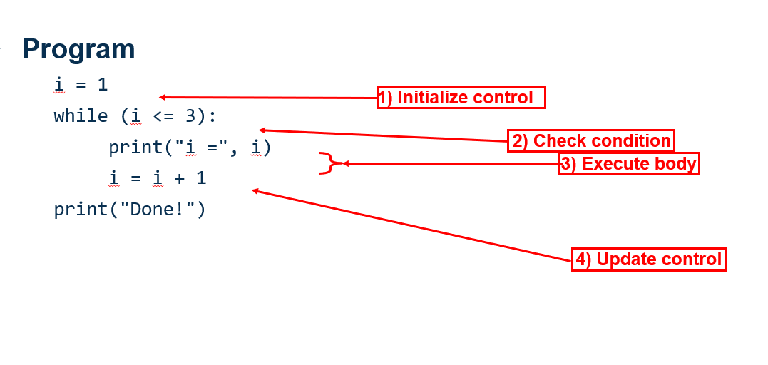
For loop- Definite loop:
A definite loop is a loop that runs a fixed number of times because the number of iterations is already known.

Structure of a for loop
for variable in sequence:
loop body
- for → keyword to start loop
- variable → changes each time (like i)
- in → used to access items
- sequence → list, range, string, etc.
- : → starts loop block
- loop body → code that repeats
Range:
range() is used to generate a sequence of numbers.
It is mostly used in for loops.

Syntax
range(start, stop, step)

Parameters
- start → where to begin (default = 0)
- stop → where to stop (not included)
- step → how much to increase/decrease (default = 1)
- range(stop)
- range(start, stop)
- range(start, stop, step)

How range(1, 4, 1) works
- Start = 1
- Stop = 4 (not included)
- Step = 1
So values of i: 1, 2, 3

Counting Forward (Ascending)
Use a positive step
for i in range(1, 6, 1):
print(i)
Explanation:
- Start = 1
- Stop = 6 (not included)
- Step = +1
Values: 1, 2, 3, 4, 5

Counting Backward (Descending)
Use a negative step
for i in range(10, 0, -1):
print(i)
Explanation:
- Start = 10
- Stop = 0 (not included)
- Step = -1
Values: 10, 9, 8, 7, ..., 1

Nested loops:
A nested loop means a loop inside another loop.
Outer loop runs first
Inner loop runs completely for each outer loop iteration
• Outer loop = rows
• Inner loop = columns

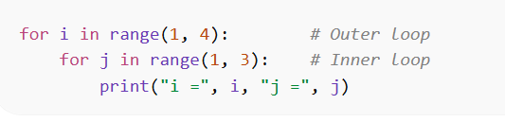

How it works
- When i = 1 → inner loop runs (j = 1, 2)
- When i = 2 → inner loop runs again (j = 1, 2)
- When i = 3 → inner loop runs again (j = 1, 2)
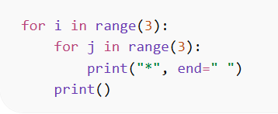
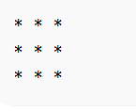
Infinite Loop
An infinite loop is a loop that never stops running.
It keeps repeating because the condition is always TRUE
Or the condition never becomes FALSE

Example
while True:
print("Hello")
This will print Hello forever
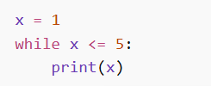

Problem: x is never updated
Condition always true → infinite loop

Loop Control Statements

1.break
Used to stop the loop immediately

Example
for i in range(1, 6):
if i == 3:
break
print(i)
Output
1
2
Loop stops when i = 3

2. continue
Used to skip the current iteration and go to the next loop

Example
for i in range(1, 6):
if i == 3:
continue
print(i)
Output
1
2
4
5
Skips only 3, loop continues

3. pass
Used as a placeholder (does nothing)

Example
for i in range(1, 4):
if i == 2:
pass
print(i)
Output
1
2
3
pass does nothing, program continues normally

LAB 5: CONTROL STRUCTURE IN PYTHON – REPETITION STATEMENT

Instructions:
- You are to code the following programs in the lab and show the output to your lecturer.
- Write comment to make your programs readable.
- Use descriptive variables in your program (Name of the variables should show their purposes)
- Note: Design the solution using pseudocode before coding

Part A – Beginner Level
- Write a program to print numbers from 1 to 10 using a for loop.
- Write a program to print even numbers from 1 to 20.
- Write a program to find the sum of numbers from 1 to 5.
- Write a program to print the multiplication table of 3.
- Write a program using a while loop and for loop to print numbers from 5 to 1 (backward).
- Write a program to print your name 5 times using a loop.
- Write a program to print multiples of 4 up to 40.
- Write a program to print odd numbers from 1 to 15.

Part B – Intermediate Level
1.Write a program to print the following pattern using nested loops:
*
* *
* * *
* * * *

Print the following pattern:
* * * *
* * * *
* * * *
* * * *
Print the following pattern:
1
2 2
3 3 3
4 4 4 4

2.Write a program to count how many numbers between 1 and 50 are
divisible by 5.
3..Write a program to reverse a number using a while loop.
(Example: 123 → 321)

PART – C
HOMEWORK

1.Write a Python program to create a multiplication table of 7.

2.Create a guessing game in Python.

The Game Logic

The Number Guessing Game revolves around a few key elements:

Generating a Random Number: The game will randomly generate a number between 1 and 10, which you will have to guess.

Limited Attempts: You will have a maximum of 5 attempts to guess the correct number. Can you solve the mystery within these attempts?

Feedback Loop: After each guess, the game will provide feedback on whether your guess is too low or too high. This will guide you in making your subsequent guesses.

Victory or Defeat: If you successfully guess the number within the given attempts, you will be celebrated for your guessing prowess. If not, the game will reveal the correct number.
3.Write a Python program to construct the following pattern, using a nested for loop.

1
2 2
3 3 3
4 4 4 4

4.Write a program to print the following pattern:
5 4 3 2 1
4 3 2 1
3 2 1
2 1
1

5. Write a program to:
- Take a number as input
- Find its factorial using a loop
Example:
Input: 5
Output: 120

6. Largest and Smallest Digit
Write a program that:
- Takes an integer as input
- Finds and displays:
  - Largest digit
  - Smallest digit
Example:
Input: 75869
Output:
Largest = 9
Smallest = 5

7. Count Total Digits
Write a program that:
- Takes an integer as input
- Uses a while loop to count the total number of digits
Example:
Input: 45892
Output: Total digits = 5

8. Count Vowels and Consonants
Write a program that:
- Takes a sentence as input
- Counts and displays:
  - Number of vowels (a, e, i, o, u)
  - Number of consonants
Ignore spaces and special characters.

